# **NO SQL LAB-3**

**Week-10**

1. Write a MongoDB query to display all the documents in the collection restaurants.

2. Write a MongoDB query to arrange the name of the restaurants in descending along with all the columns.

3. Write a MongoDB query to find the restaurant Id, name, town and cuisine for those restaurants which achieved a score which is not more than 10.

4. Write a MongoDB query to find the average score for each restaurant.

5. Write a MongoDB query to find the name and address of the restaurants that have a zipcode that starts with '10'.

**Create database**

db.createCollection("Restaurant");

Screenshot 2024-12-17 223625.png

**create table**

db.Restraunt.insertMany([{"address": {"building": "1007","coord": [-73.856077, 48.848447],

"street": "Morris Park Ave", "zipcode": "18462","borough": "Bronx"},"cuisine": "Bakery",

"grades": [{"date": new Date("2014-03-03"), "grade": "A", "score": 2},

{"date": new Date("2013-09-11"), "grade": "A", "score": 6},

{"date": new Date("2013-01-24"), "grade": "A", "score": 10},

{"date": new Date("2011-11-23"), "grade": "A", "score": 9},

{"date": new Date("2011-03-10"), "grade": "B", "score": 14}],

"name": "Morris Park Bake Shop","restaurant_id": "30075445"},

{"address": {"building":"2001","coord": [-74.005941, 40.712776],"street": "Broadway","zipcode": "10001","borough": "Manhattan"},"cuisine": "Italian",

"grades": [{"date": new Date("2015-08-20"), "grade": "A", "score": 8},

{"date": new Date("2014-06-10"), "grade": "B", "score": 4},

{"date": new Date("2013-12-15"), "grade": "A", "score": 11},

{"date": new Date("2012-09-30"), "grade": "A", "score": 9},

{"date": new Date("2011-05-12"), "grade": "A", "score": 12}],

"name": "Pasta Paradise","restaurant_id": "40092138"},

{"address": {"building": "3003","coord": [-118.243685, 34.052235],"street": "Hollywood Blvd","zipcode": "90028","borough": "Los Angeles"},"cuisine": "Mexican",

"grades": [{"date": new Date("2016-04-15"), "grade": "A", "score": 9},

{"date": new Date("2015-12-05"), "grade": "B", "score": 6},

{"date": new Date("2014-09-20"), "grade": "A", "score": 11},

{"date": new Date("2013-06-18"), "grade": "A", "score": 8},

{"date": new Date("2012-02-10"), "grade": "A", "score": 10}],

"name": "Sizzling Tacos","restaurant_id": "50065432"},

{"address": {"building": "4004","coord": [77.209021, 28.613939],"street": "Connaught Place","zipcode": "110001","borough": "New Delhi"},"cuisine": "Indian",

"grades": [{"date": new Date("2019-10-25"), "grade": "A", "score": 8},

{"date": new Date("2018-07-15"), "grade": "B", "score": 5},

{"date": new Date("2017-04-30"), "grade": "A", "score": 10},

{"date": new Date("2016-01-12"), "grade": "A", "score": 9},

{"date": new Date("2015-05-20"), "grade": "A", "score": 12}],

"name": "Spice Delight","restaurant_id": "60098765"},

{"address": {"building": "5005","coord": [76.780253, 30.728592],"street": "Balle Balle Lane",

"zipcode": "160022","borough": "Chandigarh"},"cuisine": "Punjabi",

"grades": [{"date": new Date("2020-12-10"), "grade": "A", "score": 9},

{"date": new Date("2019-08-25"), "grade": "B", "score": 7},

{"date": new Date("2018-04-15"), "grade": "A", "score": 11},

{"date": new Date("2017-01-22"), "grade": "A", "score": 8},

{"date": new Date("2016-06-30"), "grade": "A", "score": 10}],

"name": "Pind Flavors","restaurant_id": "70087654"},

{"address": {"building": "6006","coord": [77.594562, 12.971598],"street": "Vidyarthi Bhavan Road","zipcode": "560004","borough": "Bangalore"},"cuisine": "Kannadiga",

"grades": [{"date": new Date("2021-09-18"), "grade": "A", "score": 8},

{"date": new Date("2020-05-12"), "grade": "B", "score": 6},

{"date": new Date("2019-02-28"), "grade": "A", "score": 10},

{"date": new Date("2018-11-15"), "grade": "A", "score": 9},

{"date": new Date("2017-07-05"), "grade": "A", "score": 12}],

"name": "Namma Oota","restaurant_id": "80076543"},

{"address": {"building": "7007","coord": [73.856743, 18.520430],"street": "Pune-Nashik Highway","zipcode": "411001","borough": "Pune"},"cuisine": "Maharashtrian",

"grades": [{"date": new Date("2022-05-20"), "grade": "A", "score": 9},

{"date": new Date("2021-01-15"), "grade": "B", "score": 7},

{"date": new Date("2020-08-10"), "grade": "A", "score": 11},

{"date": new Date("2019-04-25"), "grade": "A", "score": 8},

{"date": new Date("2018-10-12"), "grade": "A", "score": 10}],

"name": "Misal Junction","restaurant_id": "90065432"},

{"address": {"building": "7007","coord": [73.856743, 18.520430],"street": "Shivaji Road",

"zipcode": "411001","borough": "Pune"},"cuisine": "Maharashtrian",

"grades": [{"date": new Date("2022-04-30"), "grade": "A", "score": 9},

{"date": new Date("2021-10-15"), "grade": "B", "score": 7},

{"date": new Date("2020-06-28"), "grade": "A", "score": 12},

{"date": new Date("2019-03-12"), "grade": "A", "score": 8},

{"date": new Date("2018-08-20"), "grade": "A", "score": 10}],

"name": "Vyanjan Vihar","restaurant_id": "90065432"},

{"address": {"building": "8008","coord": [79.312929, 9.288536],"street": "Temple Road",

"zipcode": "623526","borough": "Rameshwaram"},"cuisine": "Cafe",

"grades": [{"date": new Date("2021-07-22"), "grade": "A", "score": 8},

{"date": new Date("2020-02-10"), "grade": "B", "score": 5},

{"date": new Date("2019-09-05"), "grade": "A", "score": 10},

{"date": new Date("2018-04-18"), "grade": "A", "score": 9},

{"date": new Date("2017-11-30"), "grade": "A", "score": 12}],

"name": "Rameshwaram Retreat","restaurant_id": "10076543"},

{"address": {"building": "9009","coord": [80.270718, 13.082680],"street": "Anna Salai","zipcode": "600002","borough": "Chennai"},"cuisine": "Tamil",

"grades": [{"date": new Date("2022-01-15"), "grade": "A", "score": 8},

{"date": new Date("2021-06-05"), "grade": "B", "score": 6},

{"date": new Date("2020-11-20"), "grade": "A", "score": 11},

{"date": new Date("2019-08-12"), "grade": "A", "score": 9},

{"date": new Date("2018-03-25"), "grade": "A", "score": 10}],

"name": "Tamil Delicacies", "restaurant_id": "11076543"}]);

**Queries**

1.Write a MongoDB query to display all the documents in the collection restaurants.

db.Restraunt.find()

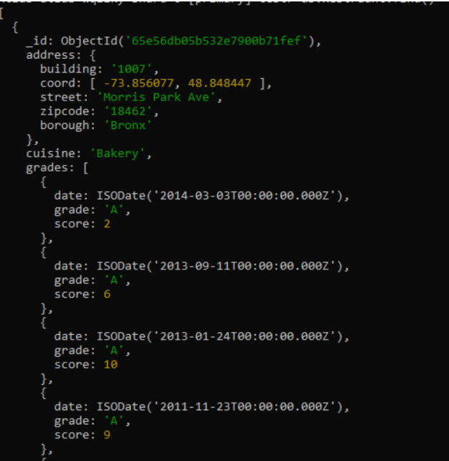

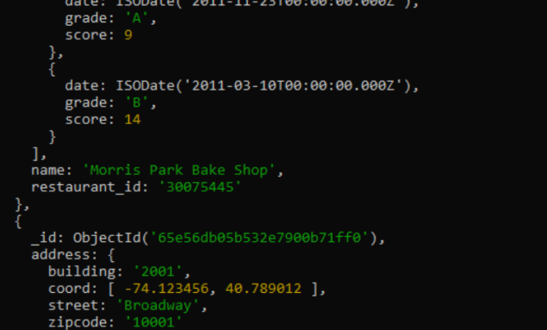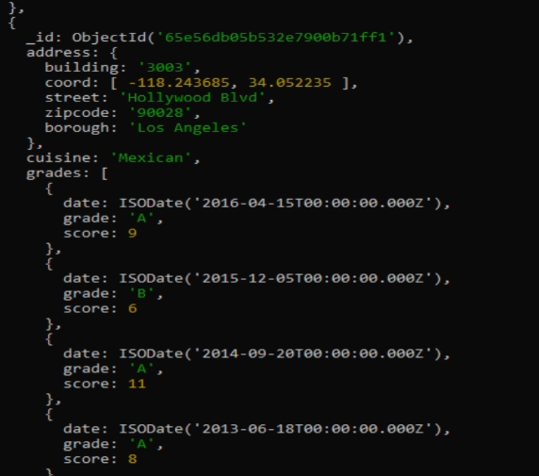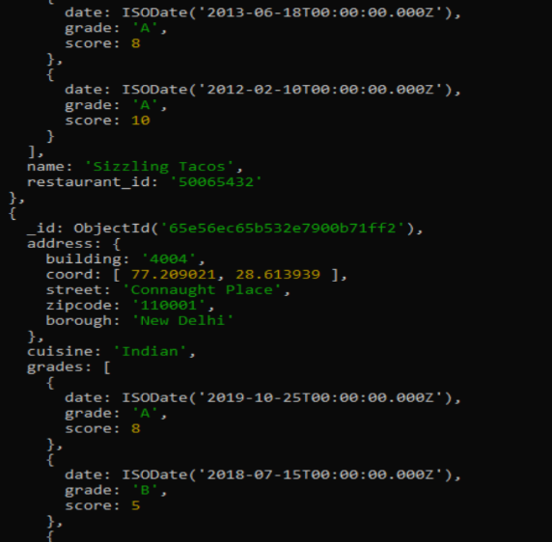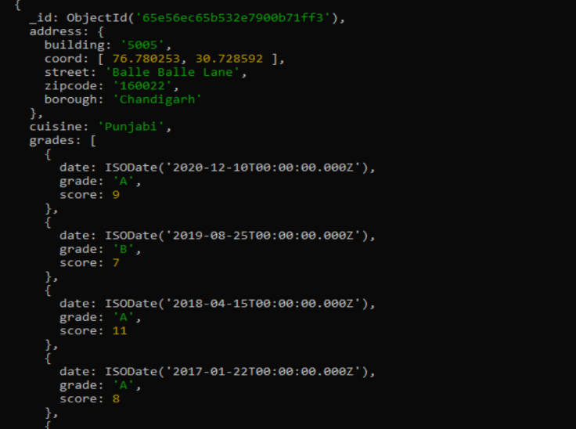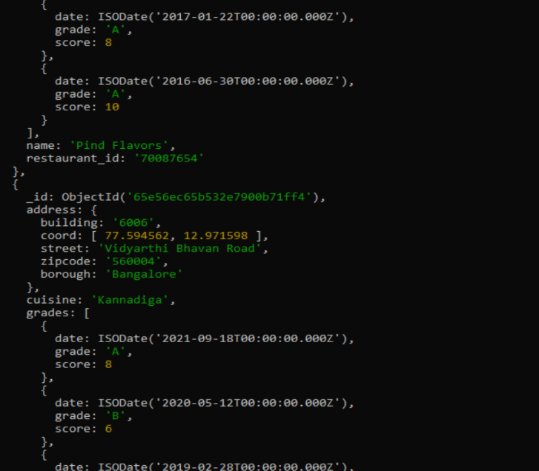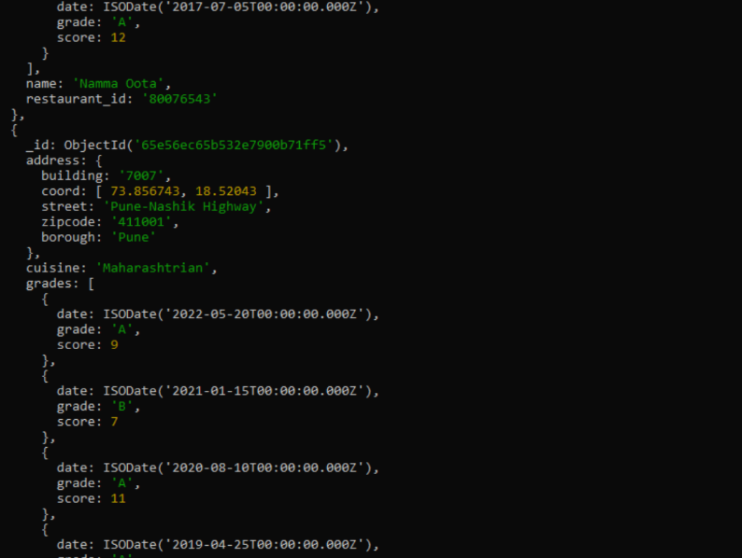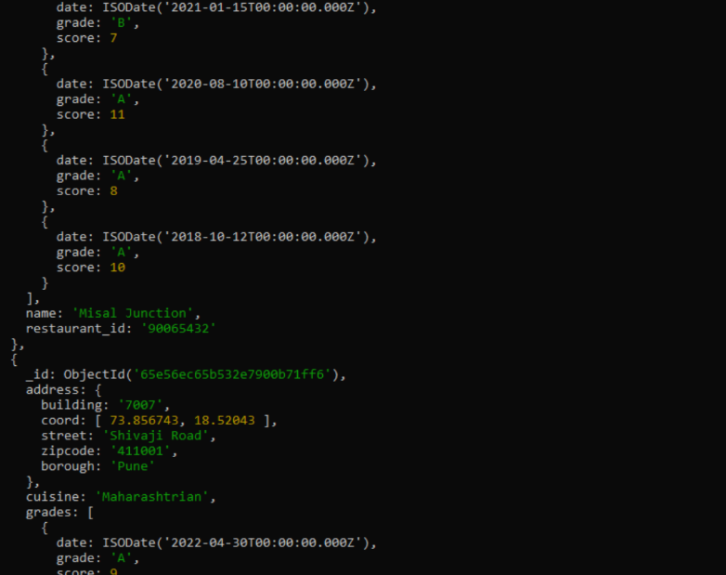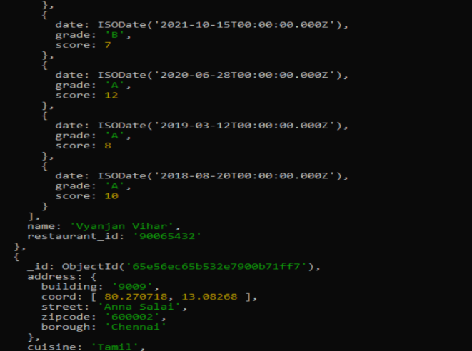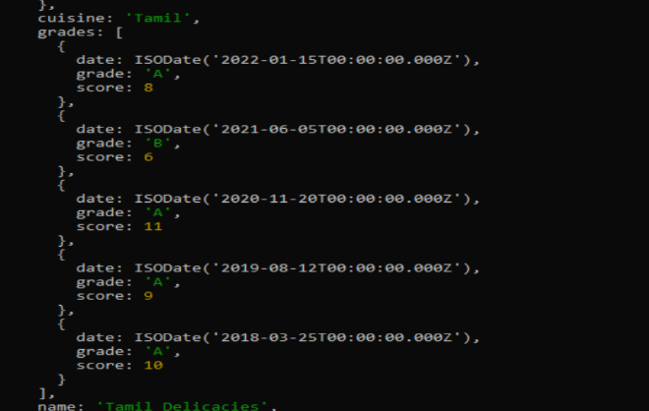

2. Write a MongoDB query to arrange the name of the restaurants in descending along with all the columns.

db.Restraunt.find().sort({ "name": -1 });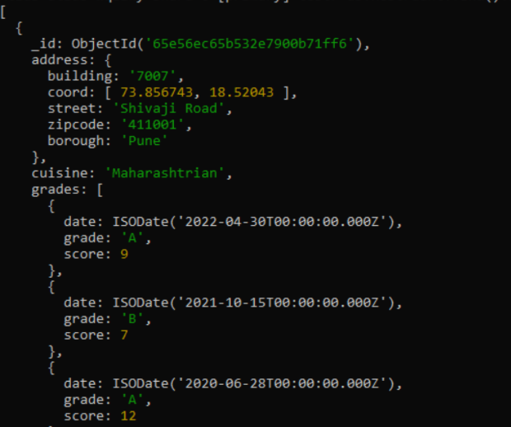

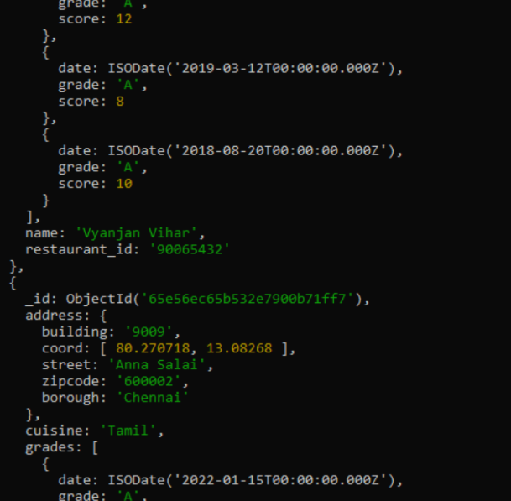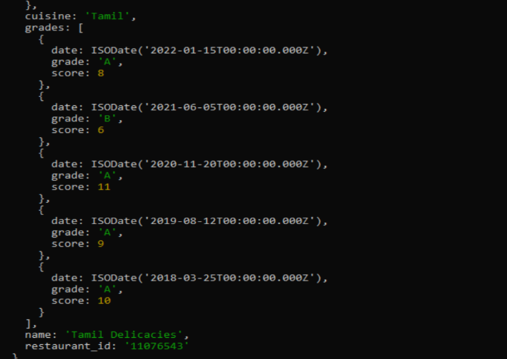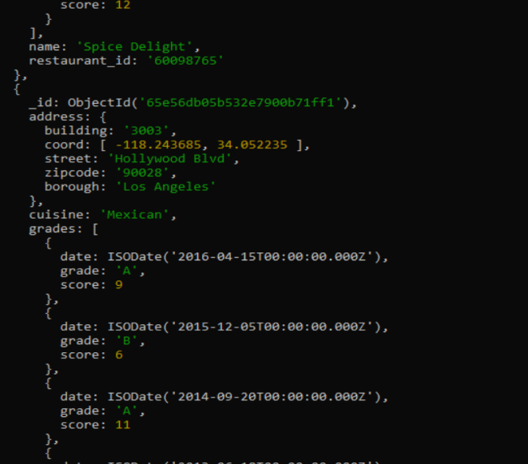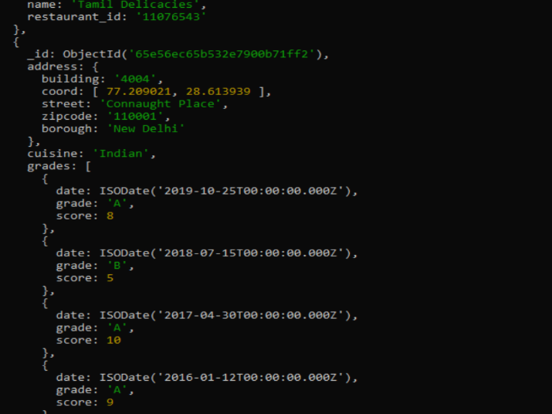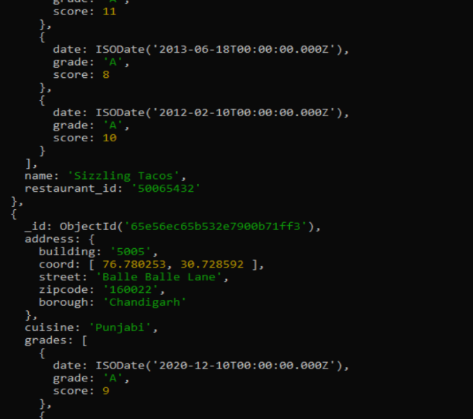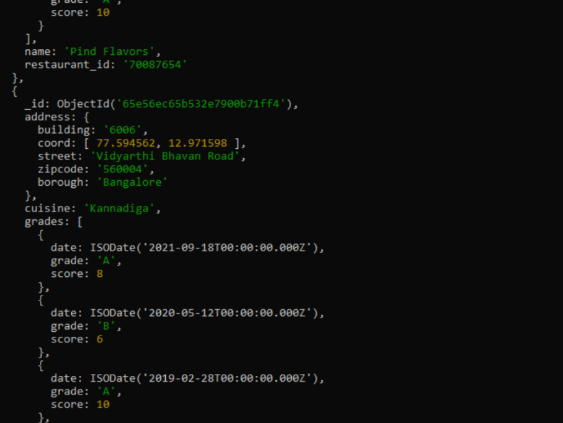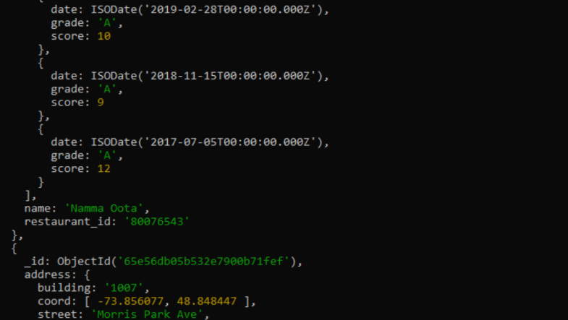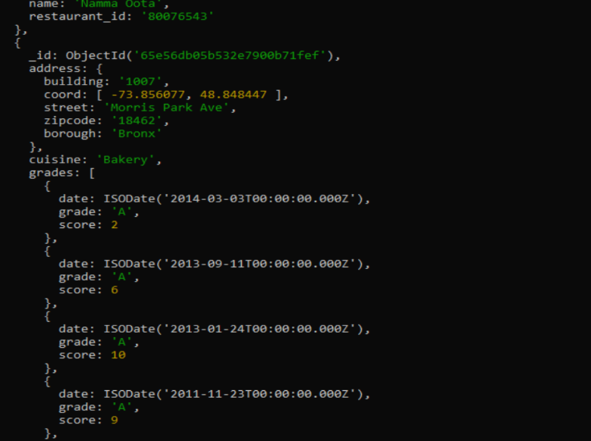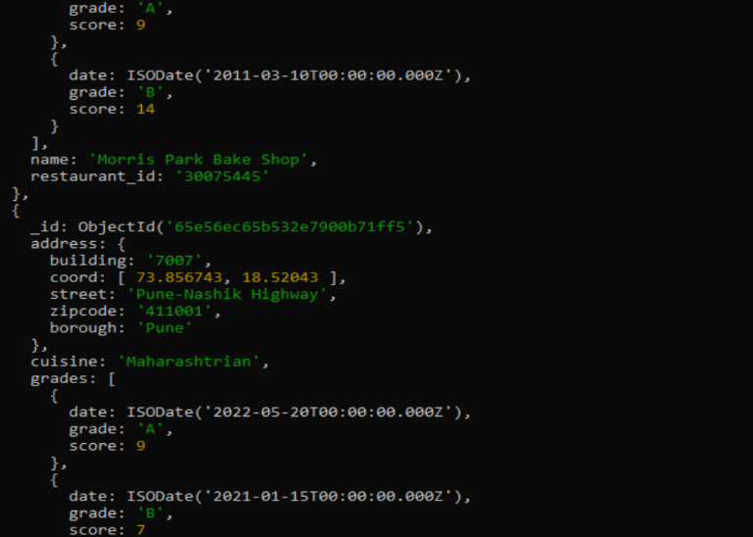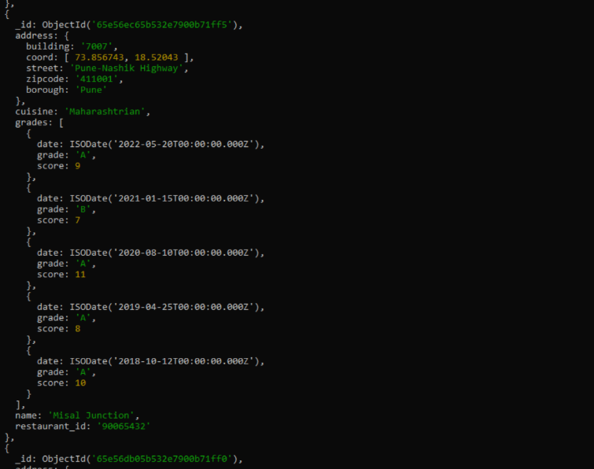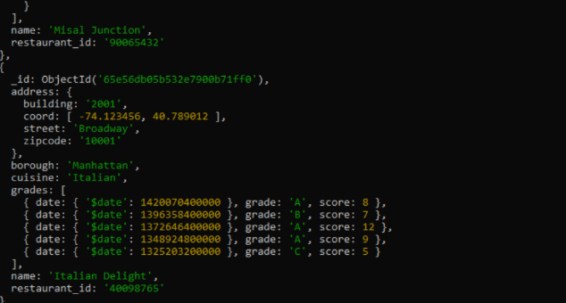

3. Write a MongoDB query to find the restaurant Id, name, town and cuisine for those restaurants which achieved a score which is not more than 10.

db.Restraunt.find({ "grades.score": { $lte: 10 } },{ _id: 1, name: 1, town: 1, cuisine: 1, restaurant_id: 1 });

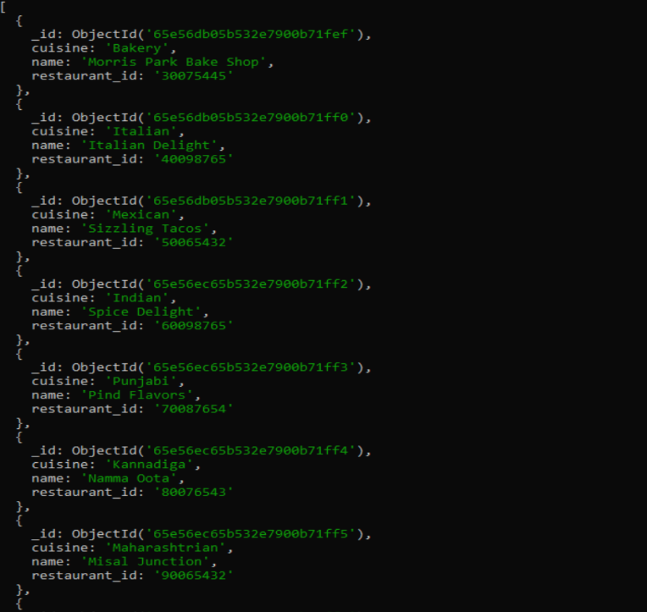

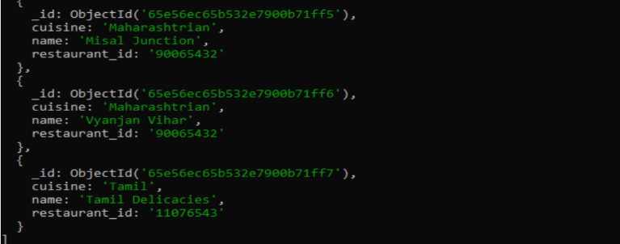

4. Write a MongoDB query to find the average score for each restaurant.

db.Restraunt.aggregate([{$unwind: "$grades"},71 {$group: {_id: "$restaurant_id",name: { $first: "$name" },averageScore: { $avg: "$grades.score" }}},{$project: {_id: 1,name: 1,averageScore: 1}}]);

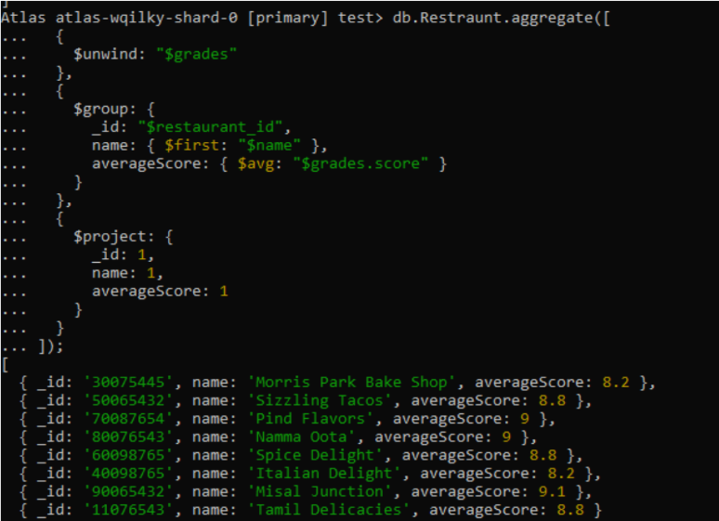

5. Write a MongoDB query to find the name and address of the restaurants that have a zipcode that starts with '10'.

db.Restraunt.find({ "address.zipcode": { $regex: /^10/ } },{ _id: 0, name: 1, "address.street": 1, "address.zipcode": 1 });

